Which policy measures could best mitigate gender inequality gaps in the future labour markets?

Lisbeth Pedersen
Head of Research Department
SFI –The Danish National Centre of Social Research

Gender equality is an important characteristic of the Nordic model. It is often discussed as a matter of morality and justice, but it is also a matter of economy and economic growth. If we had not succeeded in increasing the number of women in the labour force since the 70s our Nordic societies would have looked quite different today. We would not have experienced the growth in wealth that we have seen over the last decades, and we would not have experienced the same level of equality in income distribution for all citizens. The increase in the female labour has made it possible to develop and supply the free universal welfare services that are a crucial element of the Nordic welfare states and for creating income equality and social equality in the Nordic societies. The increased female labour supply has also made room for an increase in education among both men and women. During the years that we have seen such an increase we have actually also witnessed a decrease in male labour supply, mostly due to an increase in the amount of time spent on education. It is hard to imagine how the Nordic societies would have been without a large supply of both men and women labour.

Women's labour is an important factor for economic growth. If we can release more female labour, either by increasing female employment, increasing the number of hours worked or using women's labour in a smarter way, we can increase society's wealth and create scope for the welfare state tasks. The McKinsey Global Institute has calculated that if we had equality between the genders in the labour market in the whole world we could increase the global GDP by 26 per cent. We could not of course accommodate such an increase in the Nordic countries – to a large extent we have experienced that increase already.
When it comes to women labour supply the Nordic countries have the largest employment frequency in the western world. However, there is still room for improving gender equality, and by that increasing wealth and our ability to meet the challenges of globalisation. Though we have a fairly even distribution of employment for men and women in the Nordic countries we still see fairly permanent structural inequality in the labour market that manifests itself in a remarkably persistent pay gap between women and men.

Before answering the question about which policy measures mitigate gender inequality gaps in the future labour markets it is necessary to arrive at a clear understanding of the gender equality situation on the present Nordic labour markets.

The wage gap is very permanent
If we study the wage gap over a longer historic period of time in Denmark we find that it has been very stable since the beginning of the 1970s. During the 60s when we built the welfare state the wage gap decreased significantly, but since the 1970s – at the time when public debate was very much focused on women's liberation and we adopted the equal pay act – the wage gap has not changed much.

During the last two decades we have done a number of studies on the wage gap and the explanations to differences in male and female hourly wages. Since the late 1990s we have had very good data on individual wages. Analysis on these data shows a very stable and only very slightly decreasing wage gap over the last 20 years. A projection of the decrease will reveal that with a continuation of the current trend we will have to wait more than 100 years before we achieve equal pay.
Source: Larsen & Houlberg, 2013. Larsen, 2010

Why a permanent wage gap?
Once we believed that the wage gap would decrease over time. Women would become more and more well-educated, and when they reached the same level as men it would result in an even wage distribution. Our expectations were not realised. The figure below shows the difference in the percentage of women who have completed tertiary education compared to men. If we for instance look at Sweden, 5 per cent more women than men have such tertiary education in the year 2000 while 12 per cent more have this kind of education in 2015. The figure also shows that the increase in women's education compared to that of men has been a lot steeper in the Nordic countries than in the EU countries in general. Measured by years and level of education women are today – on average – better educated than men.

Source: EUROSTAT
Since the late 1990 Danish researchers have studied the development of the wage gap and the reasons behind the differences in men's and women's wages. The extensive analyses were made possible by the creation of a comprehensive register material with information on hourly wages for the majority of wage earners combined with information on personal characteristics and labour market attachment for every individual wage earner. Since it is an econometric analysis based on register data it was naturally limited by the information that could be drawn from what was found in the registers, but it was possible to check the meaning of a number of the important and recognised reasons for the pay gap such as: education, work experience, job function, industry, sector, family background and the extent of labour market attachment (full time, part time). The analysis showed that men's and women's different location on the labour market was the most significant factor in explaining the wage gap – that is, job function, industry and sector explain the majority of the pay gap. To make it very simple: the reason for the very permanent wage gap is that men and women occupy jobs with different remuneration, and that both the occupational structure and the wage structure have shown to be very unchangeable over time.

The segmented labour market in the Nordic countries
Taking a closer look at the distribution of men's and women's jobs in the labour market we find that the Nordic labour markets are highly segmented by gender. The figure below shows the percentage of all female and all male employees in female-dominated and male-dominated industries. The female-dominated industries are: Education, health and social activities, and the male-dominated industries are Manufacturing, Construction and Transport and Storage.

The figure shows that up to 45 per cent of the women are employed in the two female-dominated industries while up to 42 per cent of all males are employed in the three male-dominated industries.

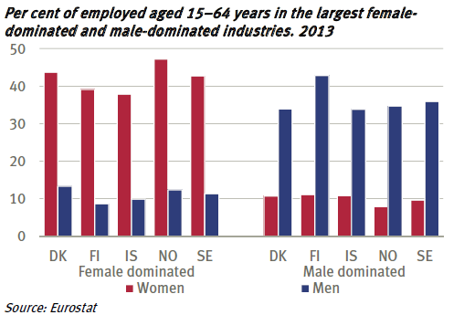
Source: EUROSTAT and Nordic Council of Ministers, 2015

In a newly published study from SFI – The Danish National Centre of Social Research the researchers (Larsen and Larsen, 2016) have calculated the change in segregation over time. First of all the study finds little change in the distribution of men and women on industries.

Per cent of women in the industries
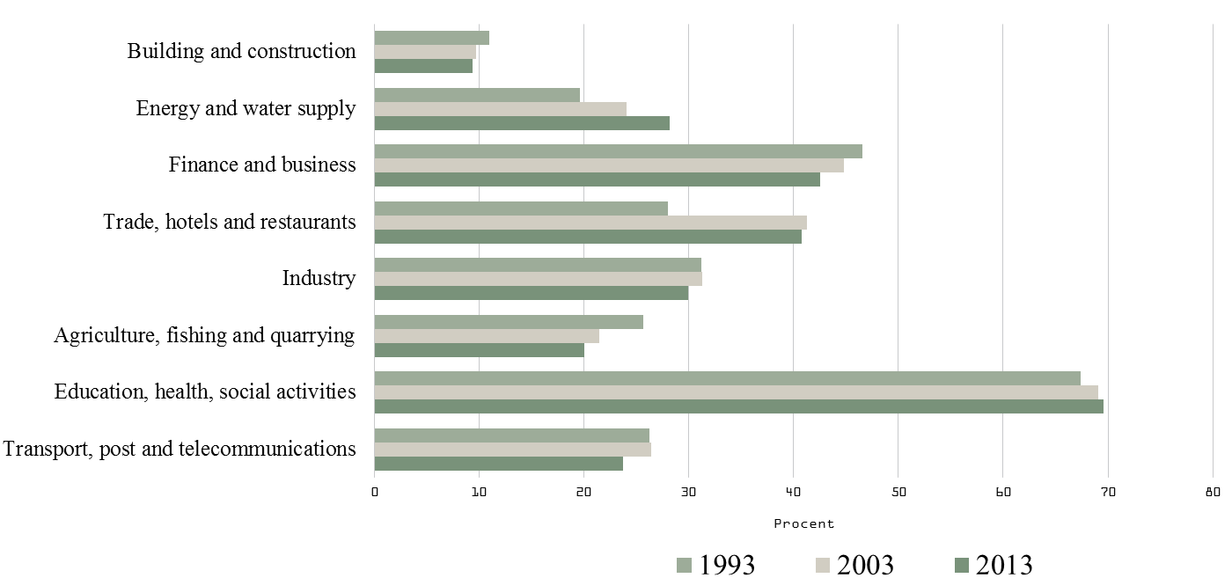
Source: Larsen and Larsen, 2016

Secondly, the changes in the distribution that we see from 1993 to 2013 are moving the distribution towards an even more segmented labour market. The percentages of women in the male-dominated industries are decreasing while the percentages of women in the female-dominated industry are increasing.

The female-dominated jobs (education, health care and social) are mostly found in the public sector. Figure 3 shows the share of women in the public sector in 1995 – the blue block – and the change between 1995 and 2012 in the Nordic countries.

Changes in the amount of women in the public sector in the Nordic countries

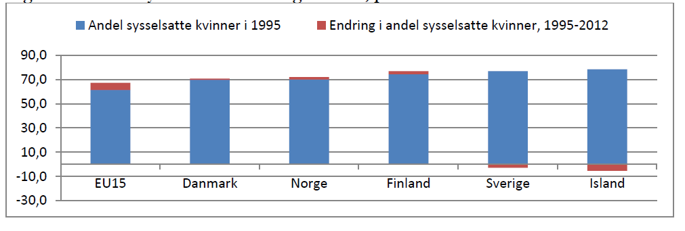

In Sweden and Iceland – which had the largest amount of women in the public sector – we see a small decrease. In the rest of the countries we see a very small increase in the amount of women in the public sector. The gender-segmented labour markets are a reality in all the Nordic countries.

The conclusion on this brief examination of gender wage differences and the segmented labour market is that the very permanent wage gap is a result of a very permanent labour market segmentation combined with a quite inflexible wage structure. That is, men and women are distributed in the same types of jobs in the same industries and in the same sectors over time, and since the wage structure barely changes over time the wage gap also remains unchanged. We could equitably ask the question if this unchanging wage gap and employment structure is a problem at all. If it is so permanent it may reflect the preferences of the two genders and of society as a whole – so why not just leave it there? One problem is of course that women are not equally rewarded for their educational investments. Women mainly have medium education which has a relatively low rate of return compared to long-term education. This is a result of collective agreements set a long time ago when the wage for women was set lower than for men – due to the two genders' different status in society, in the family and in the labour market. But the other serious problem is that the inflexible labour market and lack of mobility across sectors impose restrictions on the use of men's and women's competences and hence become an obstacle to providing the necessary manpower to the sectors and industries that lack labour. In that sense a gender-segregated labour market stunts economic growth.

Strategies to changing segmentations
What strategies could we use to make men and women more equally distributed in the labour market?
A more equal distribution of education between men and women could definitely affect the gender distribution on jobs and industries. However, this is not an easy strategy to pursue. We have been aware of the problem of an unequal educational distribution since the late 1980, and different measures have been attempted, but not with very great success. New types of measures and political initiatives are being tried, and they may over the years have an impact on the educational distribution. But changing the educational distribution may not be sufficient for changing men's and women's distribution between the public and private sectors.

In the formerly mentioned SFI study on segregation of the labour market the researchers have also studied the transition between education and jobs for men and women. In this study the researchers first picked out five majors that have an almost equal admission of men and women. Then they followed the individual labour market careers of the graduates from one to five years after graduation. It turned out that even though the two genders were almost equally represented between the majors they preferred different jobs in different sectors once they graduated. In all five groups more men than women got employed in the private sectors after graduation, and over time a decreasing or unchanged share of the women got employed in the private sector. The result indicates that not only education determinates labour market position. Men and women also have different preferences for working in the two sectors. These preferences may be formed by different factors. Some suggestions could be:

- Work culture:
Jobs and industries where major shares of employees are either men or women may develop cultures that fit one gender best. That may be a barrier of entry to the other.

- Working conditions:
Working conditions have been set differently in different collective agreements. Welfare benefits (e.g. maternity leave and sickness payments) have mostly been incorporated in the collective agreements in the areas that are dominated by women. Since these benefits are mostly used by women, it is also women who are especially attracted to jobs with these types of benefits.

- Wage differentials:
Male and female wages have been set unequally in parts of the labour market. This is due to collective agreements negotiated a long time ago when the wage for women was set lower than for men, because the two genders had a very different status in society, in the family and in the labour market. The man was the typical and often sole breadwinner and therefore got higher wages in order to be able to provide for his family. This wage structure in the Nordic labour market model is very stable and hard to change. Low-paid jobs with a strong female culture and welfare services that have a special appeal to women may not be very attractive to men.

The conclusion is that to mitigate the actual gender gaps between wages and employment we need to develop a much more gender-flexible labour market where men and women are equally attracted and equally employable in public and private sectors and more equally distributed in different industries.

Future challenges
The former section gave a brief overview of the present status on gender inequality gaps in the Nordic countries. The answer to the initial question “Which policy measures could best mitigate gender inequality gaps in the future labour markets?” will naturally depend on our expectations to what changes might occur and to the impact of these changes on the gender wage gaps.

In the future the Nordic welfare states are likely to be affected by three megatrends:

- Globalisation
- Technological changes
- Increase in life expectancy

We must expect these changes to result in:
- More price competition in industries exposed to foreign competition
- Higher inflow of labour from EU member states
- Higher inflow of less educated immigrants
- Higher demand for well-educated skilled labour (also with IT skills)

How would these changes in the labour market influence the male and female labour market and the inequality gaps?

The downward pressure would especially influence the part of the labour market where men are employed. Of course we also find women employed in the hotels, restaurants and cleaning where foreign workers would be willing to offer their work for lower wages, but most of the workers will be males. This could actually draw the gender difference in the direction of a lower wage gap.

In all sectors we will need highly qualified labour on all levels. In the future we will especially need skilled labour, but we also need to upgrade the skills among the least educated, not least among immigrants and not least among women from ethnic minorities who only have primary education.
We need to make the distribution of education more equal among men and women, but it may not be sufficient to dissolve the segregation on the labour market.

It is difficult to predict how the development will affect the demand for labour in the public sector that employs a large share of women. If we keep up or increase the size of the public sector we may experience labour shortages in the public sector because of demographic changes towards a higher average age especially for the workforce in the public sector. If we for political reasons reduce the public sector the labour market situation for the two genders will be different.

No matter what kind of changes we will see in the public sector in future we will need a more flexible labour market where both men and women have more or less the same employability in the two sectors. A shortage of labour in the public sector would result in an increased demand for male labour while a surplus of female labour due to cutbacks in public expenditure would make it necessary for women to search for jobs in the private sector. In both cases we need a higher degree of mobility between the two sectors, and we need to make jobs in both the public and private sectors available to both genders.

For whom the bell tolls
In the Nordic countries the labour market is to a very high degree regulated by collective agreements. We have a tradition for finding solutions in a dialogue between the social partners and between the social partners and the politicians. The social partners have a very central and important position in the Nordic model. Therefore we also have to rely on their ability to improve the situation.

The degree to which the labour markets are regulated by law
Index

Source: Doing Business database, World Bank 2004

It is not easy to predict the future, but in this case it seems obvious that what needs to be done to mitigate future gender inequality gaps is not different from what needs to be done to change the gravity of the present inequalities.
We definitely need a more gender-flexible labour market with equal working conditions for men and women in the private and public sectors, and over time we need to reduce the wage gap in jobs of equal value.
In this case the bell tolls for the parties in the labour market.

References

Larsen, Mona, 2010, Lønforskelle mellem kvinder og mænd i 2007. Analyser for Lønkommissionen, København, SFI – det nationale Forskningscenter for Velfærd 10:10

Larsen, Mona og Helle Sofie Bøje Houlberg, 2013. Lønforskelle mellem kvinder og mænd 2007 – 2011. København, SFI – det Nationale Forskningscenter for Velfærd 13:24.

Larsen, Mona, Helle Holt, Malene Rode Larsen, 2016. Et kønsopdelt arbejdsmarked. København, SFI – det nationale Forskningscenter for Velfærd 16:15.

Nordic Council of Ministers, 2015. Nordic Gender Equality in Figures 2015. www.norden.org/en/publications

